Dallas / Fort Worth / Irving

Irving Convention Center
To our Expo friends and North Texas Quilt Festival partners:
postponed until next year:
August 19, 20 & 21, 2021

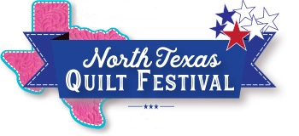
Just a few weeks ago, the spread of Covid-19 in Texas was relatively low. At that time, we felt confident we could hold the Expo safely for all Texans. However, in just a short time Covid-19 has continued to spread, and we no longer feel that it is safe to hold the event next month.

Without knowing what the coming months will bring, we have postponed Original Sewing & Quilt Expo and North Texas Quilt Festival until next year. Please mark your calendars for August 19, 20 & 21, 2021.

We will be back with a full schedule of classes, a stunning quilt show and contest, plus great shopping and many new vendors. We are very excited to host the event at our new home - the Irving Convention Center. This unique and modern venue is perfect for us, and when we can all gather again, it will be a fantastic moment for everyone.

Since we won't see you this year, we invite you to join us for Online Classes!
With just a smartphone, tablet, or computer, you can bring an Expo teacher right into the comfort of your sewing room for a live, interactive class. Plus, you can watch it, again and again, on-demand. What’s not to love? More classes just added>>

Check out the featured products page and shop with great Vendors online via SewingExpo.com. These sewing and quilt retailers are essential to our industry and will sincerely appreciate hearing from you and sharing what they’ve been up to.

You can go to www.sewingexpo.com to sign up for online classes and to shop the vendors.

