JUNE 9 – PAM PAPE
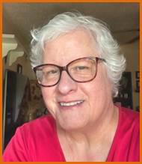
Evening Program: Crazy as a Quilt – Learn about the history and significance of special hidden meanings in 19th century quilts through intricate embroideries using different colors of thread, floss, silk ribbon, beads, and much more.

JUNE 10th WORKSHOP: The Art of Crazy Quilts
LOCATION: LAMAR BAPTIST CHURCH ANNEX
1100 Port Au Prince
Arlington, TX – House adjacent to the parking lot for Day Retreat
TIME: Setup: 8:15 a.m. Class: 8:30 – 3:00 including a 30 minute lunch break. Door Opens at 8:00.
Participants will create a 4 block Crazy Quilt wall hanging with materials and notions supplied by Pam.
Supply List is on the Guild’s website.
-------------------------------------------------------------------------------------------------------------------------------
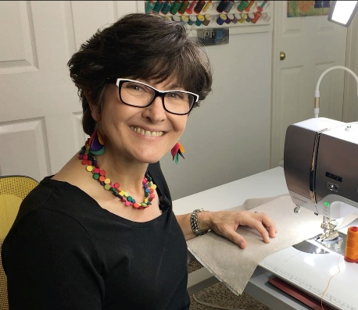
UPCOMING PROGRAMS & WORKSHOPS

JULY 14th – LINDA & CARL SULLIVAN
Evening Program: Best Tips & Tricks for Precision Piecing – Stop being frustrated with inaccurate ¼” seam allowances or finishing pieced blocks to the correct size. Learn best tips & tricks for fabric preparation, setting your machine for success, perfect pressing practices, tools & techniques for fine tuning to achieve perfect 1/4” seam allowances. Learn how to work through persnickety seam intersections & a variety of other ‘potential piecing hazards’ to achieve beautiful results.

-------------------------------------------------------------------------------------------------------------------------------

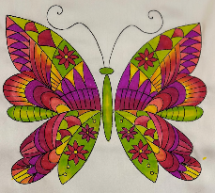
AUGUST 11th – MICHELE MARKEY
Evening Program: Fabric Painting 101 and Trunk Show – Get inspired seeing a bevy
of textile works of art using a variety of coloring & painting techniques. Watch Michele
demo how to use a wide variety of tools to paint and color on fabric.

AUGUST 12TH WORKSHOP: Butterflies & Fabric Painting 101
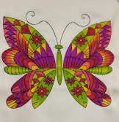
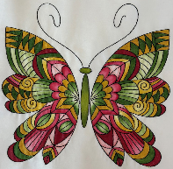
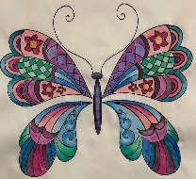
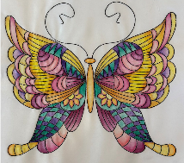
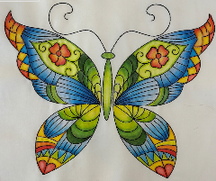
Do you want to learn to color on fabric? But don’t want to spend a lot of money on supplies? Then come to this workshop. Michele provides ALL of the tools & supplies needed for fabric blocks or a canvas bag (student choice). Choose your butterfly from 10 different choices, and learn multiple coloring & painting techniques using fabric markers, Inktense pencils, paints & fabric medium. When you’re finished you’ll have a beautiful block for a quilt, pillow or on a bag.

Maria -- PLEASE INCLUDE YOUR TEXTBOX for WORKSHOP COSTS

